CHRISTMAS PINECONE PLANT
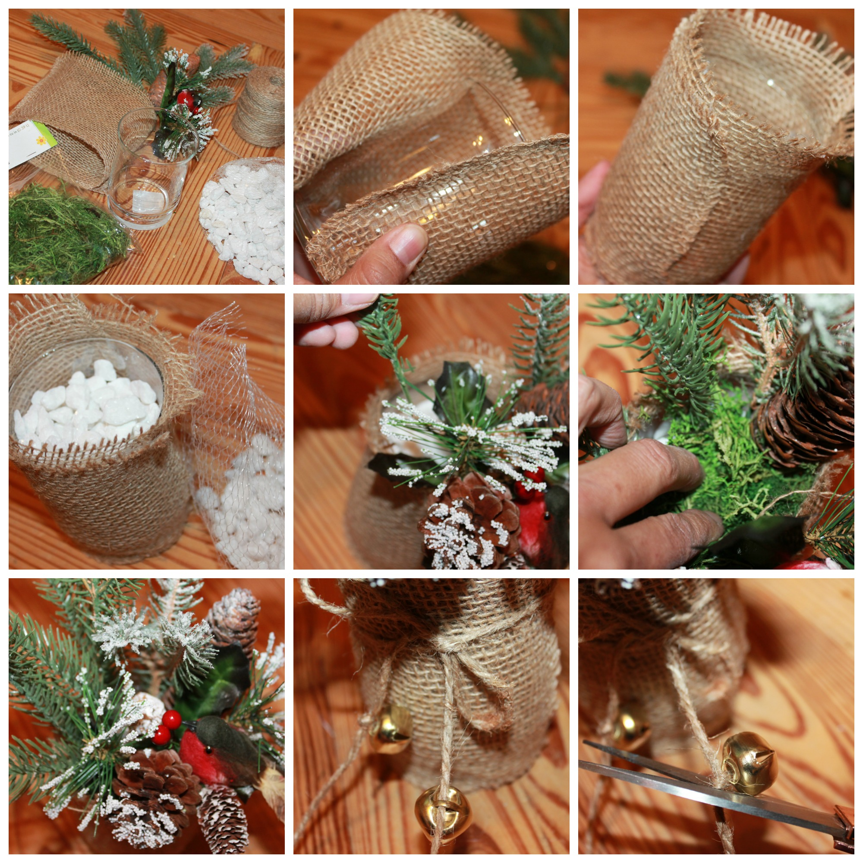

Wrap the burlap around and hot glue in place. Fill your vase almost full with rocks. Arrange your pick of leaves, holly, and pinecones in a can or jar. Add the moss to cover the rocks. Add ribbon, jute, bells, tag, or other embellishment to call it your own.
