DIY filler ornament
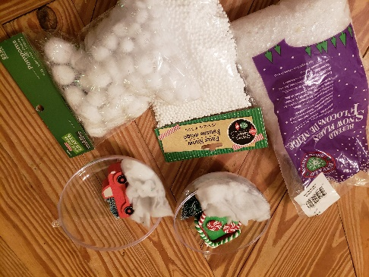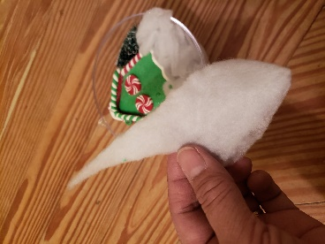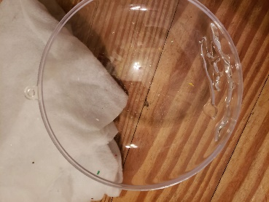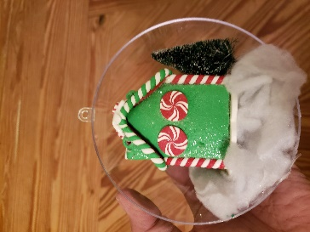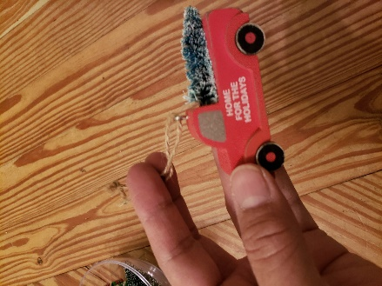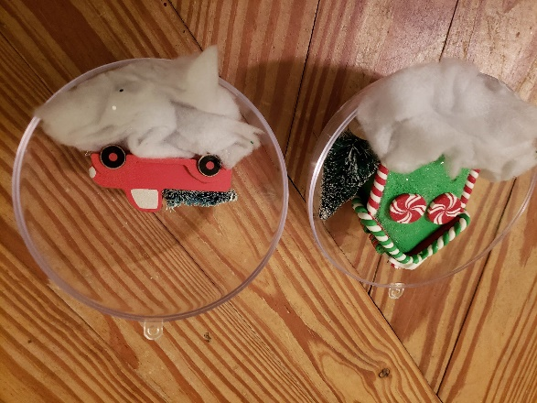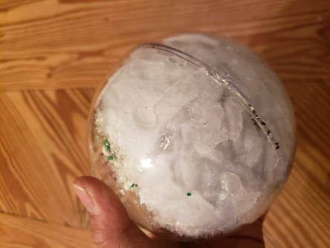

Choose your filler such as gingerbread houses, red trucks with trees, foliage, polar bears, etc. Open up your ornament. Cut pieces of snow fluff and hot glue to bottom half of ornament-do for both sides. Then hot glue the house for example to the fluff, along with the tree and truck. Whatever you choose, make sure the hole in the ornament is facing up and your objects are centered. Add fake snow glitter, flakes, or white pom poms as desired. Snap the ornament halves to make a whole, add a ribbon to hang, and enjoy your awesomeness!

